PROJECT DEVELOPMENT PHASE

SPRINT-4

|  |  |
| --- | --- |
| Date | 16 November 2022 |
| Team ID | PNT2022TMID42442 |
| Project Name | IoT based safety gadget for child safety monitoring and notification |
| Maximum Marks | 8 Marks |

**Current Information of the child location in Web UI:**

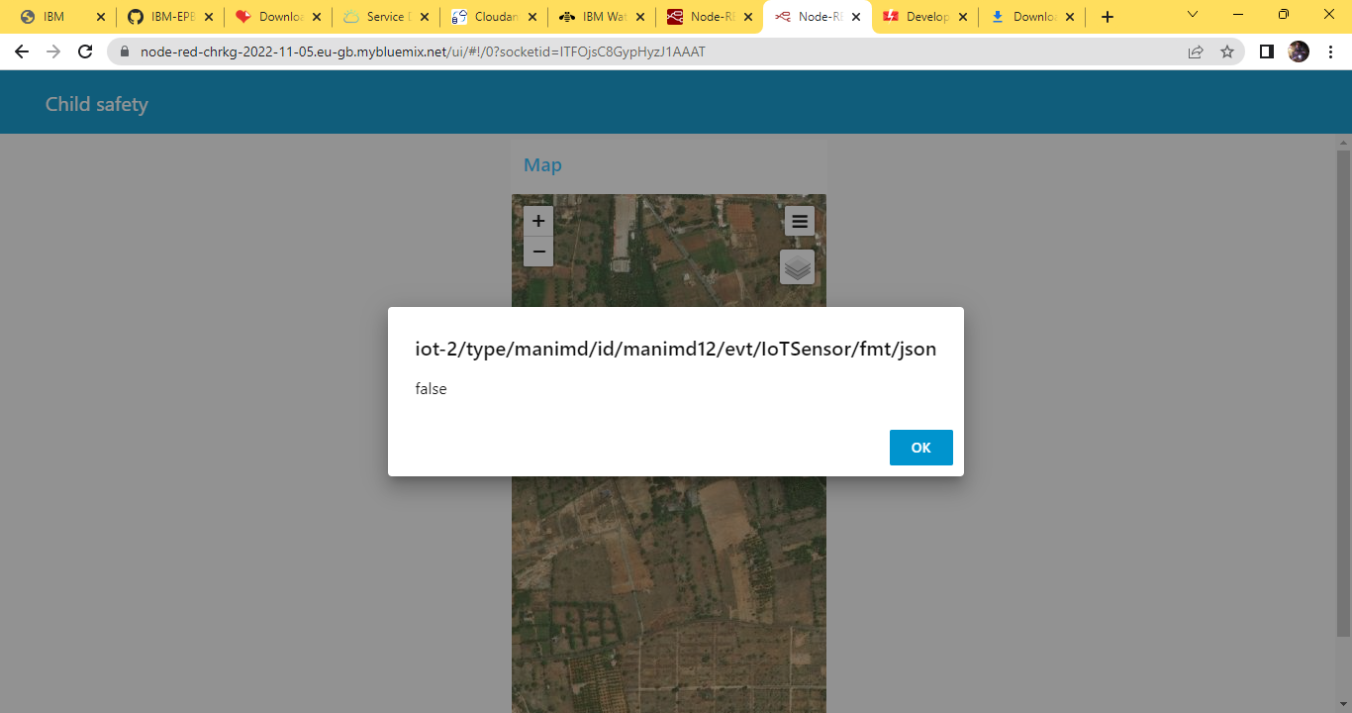

Cloud database storing :

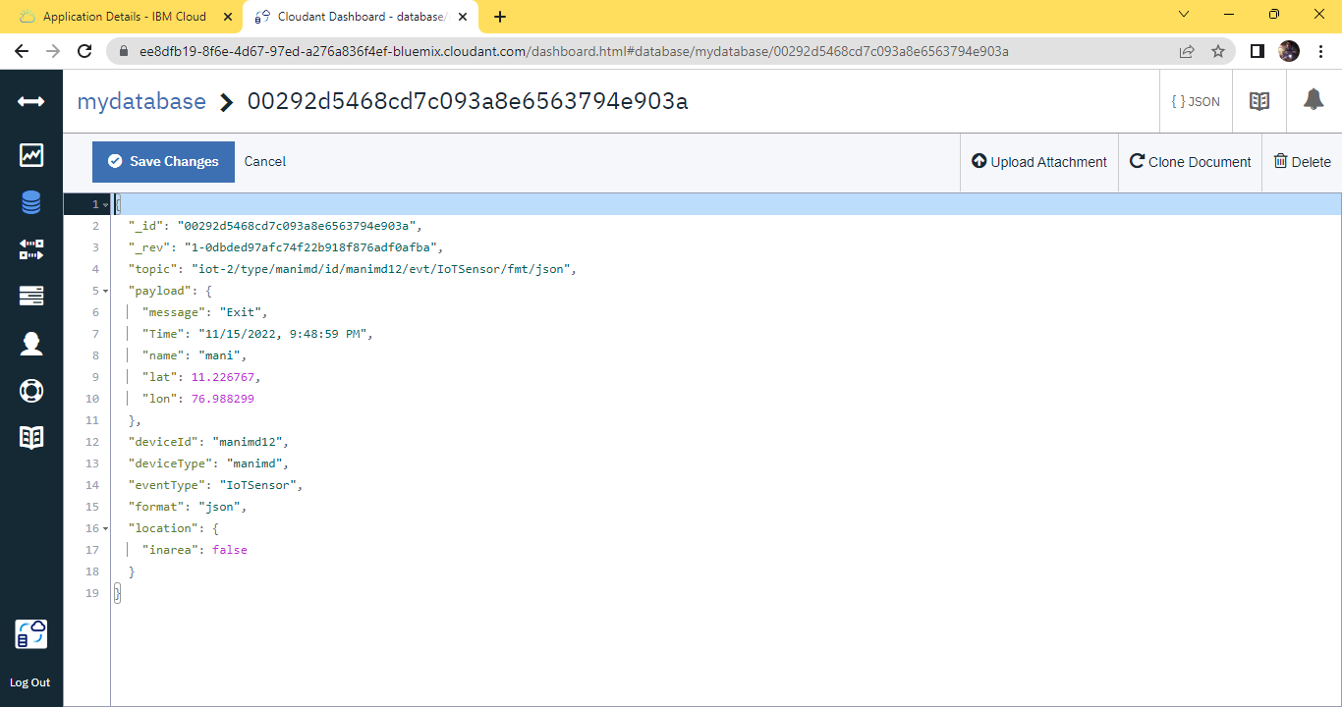

Alert Message in User:

